**Weather data for the city of Aarhus in Denmark and Brasov in Romania**

**Introduction**

Weather models very commonly used on a day-to-day basis. Using the past and the current weather data observed, forecast the future movement of the weather. Weather forecast concentrates on taking current perceptions of climate and handle these information with the help of computer models to calculate the future condition of climate. There are various factors affecting the change in weather few of which is as follows Temperature, Humidity, Pressure, Dew point, Wind speed, Wind direction, Visibility. All the above mentioned variables serve as input for the model.

Climate research plays a key role in understanding the challenge posed by climate and in developing the necessary solutions to benefit the environment, society and the business sector. The raise in the temperature causes global warming which in turn leads to the raise in the sea water level. The greenhouse effect or raise in the carbon di oxide also influences directly in the raise of global temperature. To predict the weather it is essential to identify all the factor influencing the changes.

**About The Data**

The data is obtained for the city of Aarhus in Denmark and Brasov in Romania. The data is calculated on a random time in a day to identify the variation across the day and at the end the mean value is consider for during that time period. The data includes values from all the 7 days during the time period. Multiple records are noted throughout the day to accurately identify the range. The variables are calculated in different denominations such as [Dew point](http://en.wikipedia.org/wiki/Dew_point) in degrees Celsius, Humidity (percentage), Pressure in mBar, Temperature in degrees Celsius, Wind direction in degrees and Wind speed in kilometers per hour (kph).

**Data Structure**

The data consists of the following columns

1. Temperature
2. Humidity
3. Pressure
4. Dew point
5. Wind speed
6. Wind direction
7. Visibility
8. Timestamp

Let’s look at the description of all these variables in depth below.

Temperature :

Earth is getting warmer; the cause could be human activity or natural variability. Since the beginning of the industrial revolution, it is observed as an evidence of risen temperature. Of course, the temperature fluctuates by many degrees everyday where we live, by accumulation of this fluctuation now had accrued and lead and to be in global warming. The global temperature record indicates an average over the entire surface of the planet. A one degree global change is significant as because it takes a huge amount of heat to warm all oceans, atmosphere and land. Since the year 2000, land temperature changes are 50% greater in the US than ocean temperature changes; two to three times greater in the Arctic Ocean and Antarctic Peninsula, warming is more in the Arctic Ocean, and the next is in the Indian and Pacific oceans and the third largest in the most of Atlantic Ocean. The global temperature changes mainly depends on how much energy the planet receives from the sun and how much it radiates back.

Humidity :

It tells the moisture content of the atmosphere. When the humidity is high it feels oppressive outside because of sweat doesn’t evaporate. When the humidity is low you feel cooler but moisture evaporated. The relative humidity is dependent on air temperature. If the water vapour content stays the same and the temperature drops the relative humidity increases.

There are three fundamental estimations of moistness: total, relative and particular. Outright dampness is the water substance of air at a given temperature communicated in gram per cubic meter.[2] Relative moistness, communicated as a percent, measures the flow total stickiness with respect to the most extreme (most elevated point) for that temperature. Particular mugginess is a proportion of the water vapor substance of the blend to the aggregate water content on a little premise.

Pressure :

Air gets lighter with increasing altitude. Atmospheric pressure is around 1014 mill bars at sea level. At sea level, the air that surrounds presses down the bodies at 14.5 pounds per square inch.

Pressure (symbol: p or P) is the [force](https://en.wikipedia.org/wiki/Force) applied perpendicular to the surface of an object per unit [area](https://en.wikipedia.org/wiki/Area) over which that force is distributed. [Gauge pressure](https://en.wikipedia.org/wiki/Gauge_pressure) (also spelled gage pressure)[[a]](https://en.wikipedia.org/wiki/Pressure" \l "cite_note-1) is the pressure relative to the ambient pressure.

Dew Point:

Dew point may drop by some possible influences; as when the temperature drops it’s enough to get fog and dew, water condenses out of the air and lowering the dew point. When it is hotter outside, the water will evaporate from the ground faster and the dew point raises. And when it is hottest outside, there is more wind and the mixing of low altitude and high altitude air lowers the dew point. Dew point is dependent on temperature. Dew point is a more reliable indicator of humidity because it is not changed by a change in air temperature and doesn’t fluctuate much throughout the day.

Wind Speed :

Wind, which is as called as air movement, is integral to all types of weather conditions. Wind speed is caused by air moving from high pressure to low pressure, usually due to changes in temperature. Wind speed is influenced by various elements and circumstances, working on shifting scales (from smaller scale to full scale scales). There are likewise connections to be found between wind speed and wind course, strikingly with the weight inclination and landscape conditions.

Wind Direction :

Wind direction is obtained by the [direction](https://en.wikipedia.org/wiki/Direction_(geometry)) from which it initiates. For example a wind coming from the south is shown as 180 degrees and the one from the east is 90 degrees. Air pressure, which is largely caused by differential heating of the air by the sun and ground conditions, controls the way air flows. Instruments can be utilized to quantify wind direction, for example, the windsock or a wind vane. Both of these instruments work by moving on air resistance. The way a climate vane is pointed by winning winds demonstrates the direction of wind direction.

Visibility :

Visibility is a measure of the distance at which an object or light can be clearly seen . visibility affects all forms of traffic, aviation and sailing. Visibility to transparency of air; in dark visibility still the same as in daylight for the same air. If the temperature is warm, the atmosphere has a greater capacity to hold water in its vaporous state than if it is cold. Vapour can change into visible water in one other way.

Timestamp:

Timestamp records the time at which the values are recorded. It is of the form mm/dd/yyyy and it also provides the time at which the values are noted.

**Data imported with Zeppelin :**

Commands used for importing data into Zeppelin.

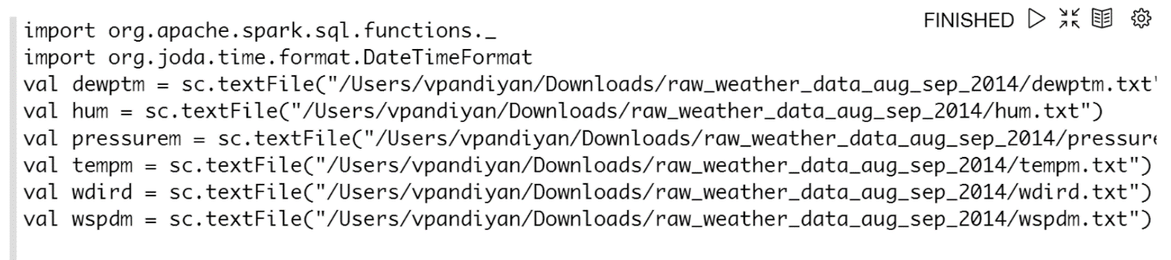

When displayed the table looks like.

